NFCSD TEACHER’S K-12 TECHNOLOGY CONTINUUM
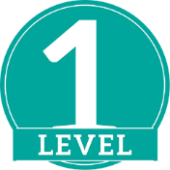 | LEVEL 1A: Learning Management System: (Microsoft Teams)  1A.1 - Teachers can access Office 365 and the various products to complete the following skills:  1A.1.a - Save and share documents, spreadsheets, Forms, and presentations via OneDrive  1A.1.b - Access email and communication systems (post, chat, and video conference)  1A.1.c - Teachers can utilize online booking software to schedule PD and parent conferences  LEVEL 1B: Accessing Core Digital Resources  1B.1 - Teachers can access Education Law 2D compliant and district approved digital resources (Ex Clever, Investigations, Amplify, Castle Learning, NewsEla, Nearpod) – Click HERE to view all resources  LEVEL 1C: Assigning and Assessing Core Digital Resources  1C.1 - Teachers can assign and assess student work using Ed Education Law 2D compliant software  1C.2 - Teachers can access data from digital resources to guide instruction  LEVEL 1D: Accessibility Features  1D.1 – Teachers can list at least 5 accessibility features that will support curricular access  1D.2 – Teachers can access and utilize at least 5 accessibility features (i.e., Dictate, Immersive reader,)
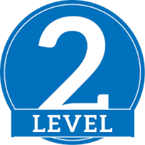 | LEVEL 2A: Learning Management System: (Microsoft Teams)  2A.1 - Teachers can schedule, attend, conduct, and record virtual meetings for remote classes  2A.2 - Teachers can schedule and evaluate assignments in Teams  2A.3 - Teachers can alter the settings and management of Teams (Ex. Add channels, tabs, files, student access, etc)  2A.4 - Teachers can screencast and post lessons with Stream or other screen capturing software  LEVEL 2B: Webpage Design:  2B.1 - Teachers can create and maintain a district webpage to ensure a digital presence using high end apps such as embed codes, accordion filing systems, and live documents  LEVEL 2C: Accessibility Features  2C.1 – Teachers can match a specific accessibility feature to a learning need of a student, for at least 5 accessibility features
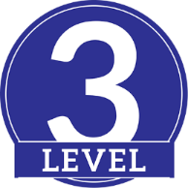 | LEVEL 3A: Core Digital Resources:  3A.1 - Teachers can integrate district approved core digital resources within a Microsoft Teams - Click HERE to view all resources  LEVEL 3B: Learning Management System: (Microsoft Teams)  3B.1 - Teachers can build and share rubrics for grading  3B.2 - Teachers can integrate outside programs (Ex Nearpod, Flipgrid, Lumio) into assignments  3B.3 - Teachers can utilize and integrate OneNote Class Notebooks into assignments and classroom rituals  LEVEL 3C: Accessibility Features  3C.1 – Teachers can use accessibility features in a new way  3C.2 - Teachers will utilize district approved accessibility features that were not part of any training  LEVEL 3D: Future Software  3D.1 - Teachers can utilize eDoctrina to access teacher dashboard information such as assessment data  3D.2 - Teachers can conduct classes using Augmented and Virtual Reality devices/software  3D.3 - Techers can incorporate the new NYS Computer Science Standards into their curriculum  3D.4 – Once teachers have successfully completed all above standards, they will be recognized as a Teacher Innovator  3D.4.a – Teachers can begin piloting the next generation of Learning Management Systems (Ex Canvas, Schoology)  3D.4.b – Teachers can effectively utilize Efficiency Delivery Systems (Ex Multicasting)

